**Lab Assignment 11**

**Student Name: Chauhan Vandana Ramdayal**

**Student Id: AF0411629**

**Topic:Exception Handling**

Q1. Write a Python program to handle a ZeroDivisionError exception when dividing a number by zero.

Code:

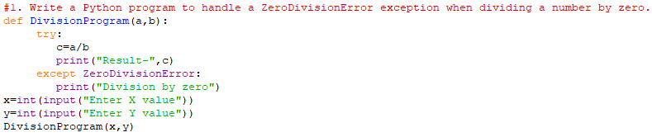

Output:



Q2. Write a Python program that prompts the user to input an integer and raises a ValueError exception if the input is not a valid integer.

Code:

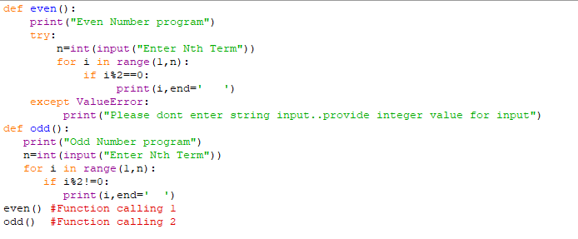

Output:

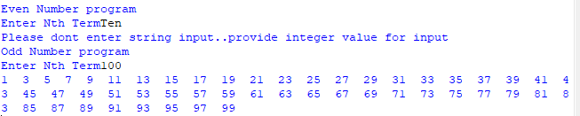

Q3. Write a Python program that opens a file and handles a FileNotFoundError exception if the file does not exist.

Code:

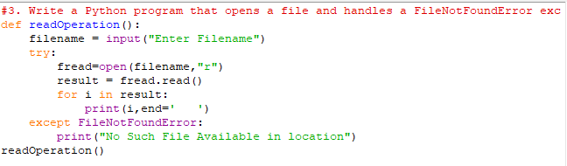

Output:



Q4. Write a Python program that prompts the user to input two numbers and raises a TypeError exception if the inputs are not numerical

Code:

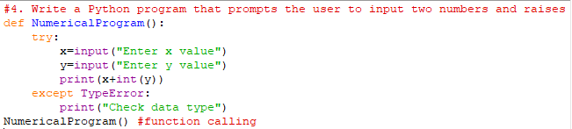

Output:

